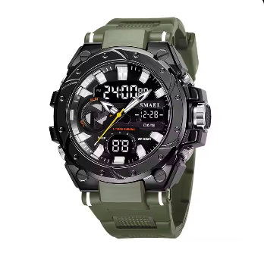

***Product Name***: Samael Men's Digital Sports Watch

**Description:**

The watch blends analog and digital displays, providing detailed timekeeping. The digital screen shows the time in a **24-hour format**, along with the **day, date, and various functions**. It includes a **backlight**, making it easy to read in low-light conditions.

**Specifications:**

* **Brand:** SMAEL
* **Display Type:** Analog-Digital
* **Case Material:** Resin
* **Strap Material:** Silicone
* **Water Resistance:** Up to 50 meters
* **Functions:** Time, Date, Day, Alarm, Stopwatch, Backlight
* **Dial Color:** Black
* **Strap Color:** Green

**Price:**

**$20 to $30**.